# Course: Artificial Intelligence and Machine Learning Code: 20CS51I

**WEEK- 11**

**NATURAL LANGUAGE PROCESSING**

**Session 2**

**11.6 TEXT PROCESSING TASKS**

Text data derived from natural language is unstructured and noisy. Text preprocessing involves transforming text into a clean and consistent format that can then be fed into a model for further analysis and learning.

* Text preprocessing is an important step for natural language processing (NLP) tasks.
* It transforms text into a more digestible form so that machine learning algorithms can perform better, and depending on how well the data has been preprocessed; the results are seen.
* Text preprocessing improves the performance of an NLP system.
* For tasks such as sentiment analysis, document categorization, document retrieval based upon user queries, and more, adding a text preprocessing layer provides more accuracy.

Some of the preprocessing steps are:

* Tokenization
* Removing Stop words
* Spelling correction
* Stemming
* Lemmatization

We will be using NLTK to perform all NLP tasks. If NLTK is not yet installed in your system, go to Anaconda Command prompt and perform the following steps:

* **pip install nltk**

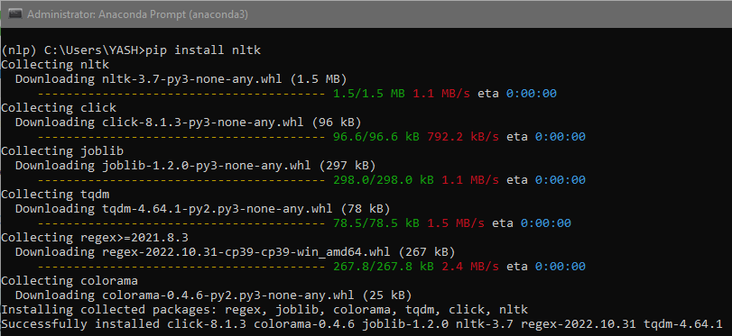

* Then, enter the python shell in your terminal by simply typing **python**
* Type **import nltk**
* Type **nltk.download(‘all’)**

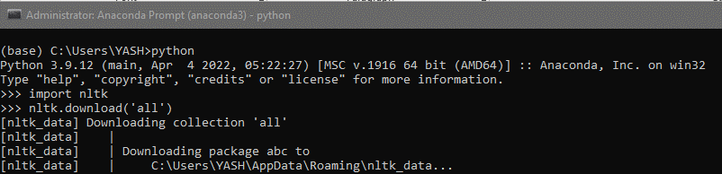

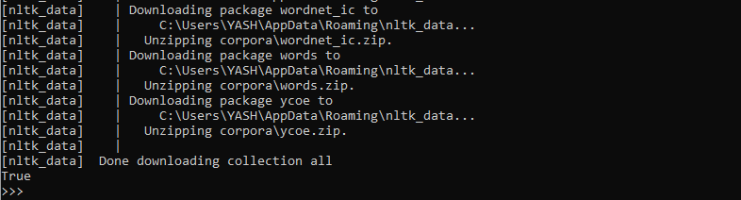

The above installation will take quite some time due to the massive number of tokenizers, chunkers, other algorithms, and all of the corpora to be downloaded.

**11.6.1 Tokenization**

Token in a text document refers to each “entity” that is a part of whatever was split up based on rules. For examples, each word is a token when a sentence is “tokenized” into words. Each sentence can also be a token, if you tokenized the sentences out of a paragraph. So basically, tokenizing involves **splitting sentences and words from the body of the text.**

**NLTK Tokenizer Package**

Tokenizers divide strings into lists of substrings. The given document can be tokenized into sentences or words based on our requirement.

**1. Sentence tokenization**

The given document is divided or tokenized into sentences.

**Syntax:**

**nltk.tokenize.sent_tokenize(text, language='english')**

returns a sentence-tokenized copy of text, using NLTK’s recommended sentence tokenizer. (currently PunktSentenceTokenizer for the specified language).

**Parameters:**

*Text (str)* – text to split into sentences

*Language(str)* – the model name in the Punkt corpus. By default it will be English.

**Example:**

The following example reads a text file and tokenizes it into sentences.

* Import the sent_tokenize method from nltk.tokenize package



* Read the text file using open method

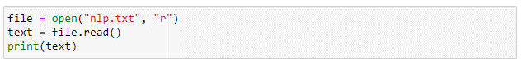

**Output:**

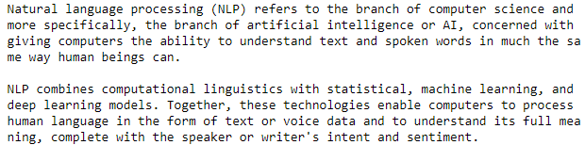

* Divide the text into sentences using the sent_tokenize method



* Print the sentences to see how the method has divided the text into sentences.

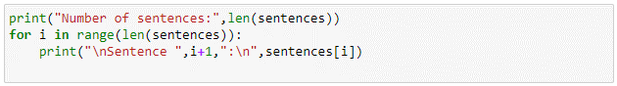

**Output:**

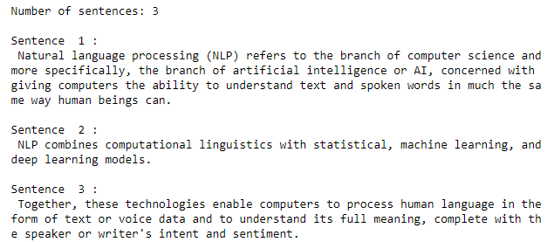

**2. Word tokenization**

The given document is divided or tokenized into words.

**Syntax:**

nltk.tokenize.word_tokenize(text, language='english', preserve_line=False)

returns a tokenized copy of text, using NLTK’s recommended word tokenizer (currently an improved TreebankWordTokenizer along with PunktSentenceTokenizer for the specified language).

**Parameters**

*text (str)* – text to split into words

*language (str)* – the model name in the Punkt corpus

*preserve_line (bool)* – A flag to decide whether to sentence tokenize the text or not.

**Example:**

For the text file used in previous example, let us find the word tokens.

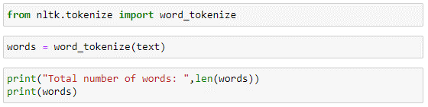

**Output:**

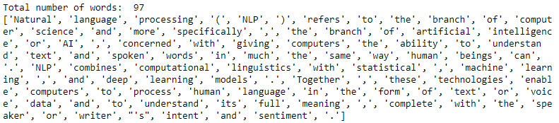

The tokens generated will contain special characters such as comma, dot, parentheses, apostrophe etc. We may have to remove these special characters, and stop words to generate the vocabulary of our text document.

**3. Visualizing Frequency Distribution of words**

The standard method for visualizing the word frequency distribution is to count how often each word occurs in a corpus and to sort the word frequency counts by decreasing magnitude. We need to create a Bag of Words (BoW), which is a statistical language model used to analyze text and documents based on word count.

**Example:**

To visualize the frequency distribution, let us consider opinions given by customers about a hotel.

* Read the “Opinion.txt” text file which contains opinions given by multiple customers

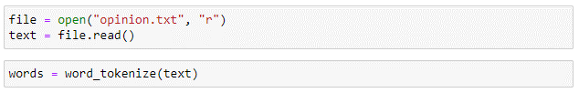

* **Creating the FreqDist**

Without the NLTK package, creating a frequency distribution plot (histogram) for a BoW is possible, but will take multiple lines of code to do so. Through the use of the FreqDist class, we are able to obtain the frequencies of every token in the BoW with one single line of code:

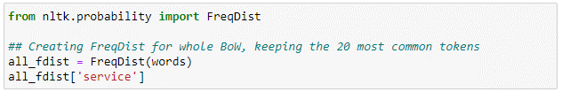

**Output**:

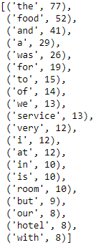

* **Visualizing Frequency Distribution using matplotlib**

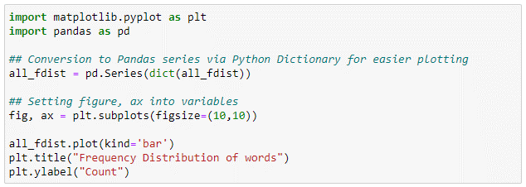

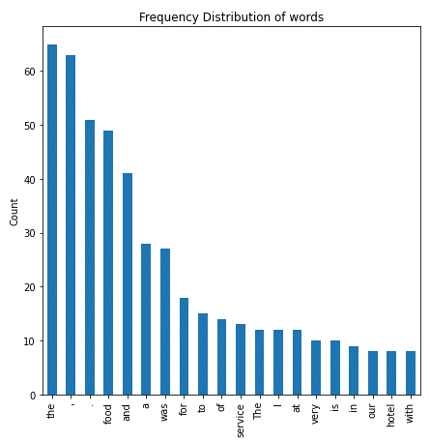

As we can see, the frequency distribution contains frequencies of tokens like ‘the’, ’to’, ‘of’ which are considered as stop words. It also contains special characters and tokens with different case are treated differently. To overcome these issues, we have to perform text cleanup as follows:

* **Converting the text to lower case letters.**



* **Removing special character from data**



* **Removing words with numbers from data**



* **Removing Stopwords**

Stop words are a set of commonly used words in any language. For example, in English, “the”, “is” and “and”, would easily qualify as stop words. In NLP and text mining applications, stop words are used to eliminate unimportant words, allowing applications to focus on the important words instead When we visualize the frequency distribution after text cleaning, it will be as follows:

NLTK has an inbuilt list of stopwords. We can also create our own stopword list and use it based on our requirements. The following code removes the stopwords from the text.

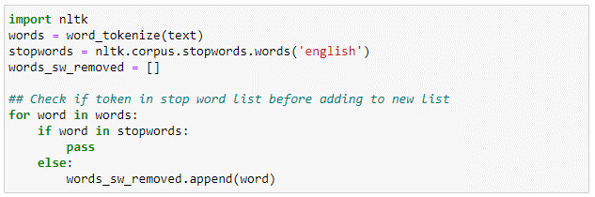

When we draw the Histogram after the text cleaning, it would look like the below figure.

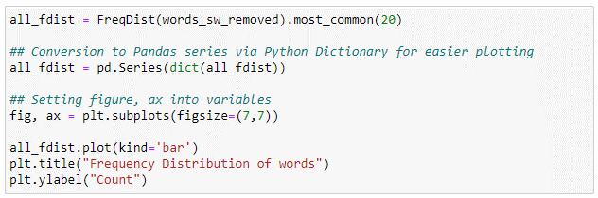

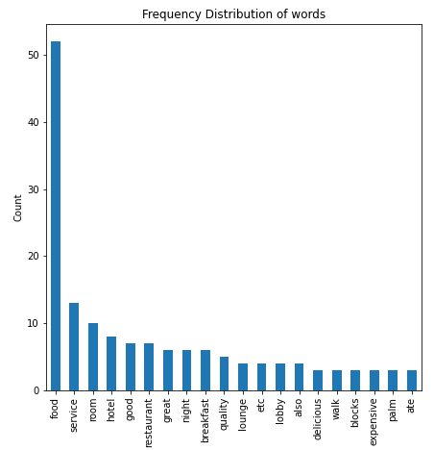

**4. Visualize with word cloud**

A word cloud is a collection, or cluster, of words depicted in different sizes. The bigger and bolder the word appears, the more often it’s mentioned within a given text and the more important it is.

To draw a word cloud, install it through pip command as follows:

pip install wordcloud

**Example:**

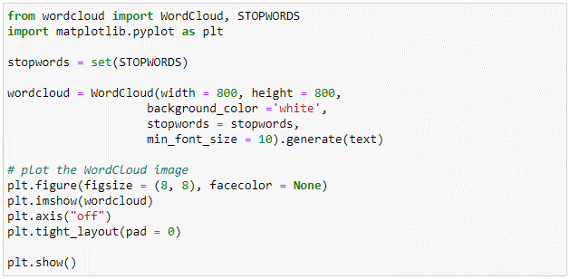

**Output:**

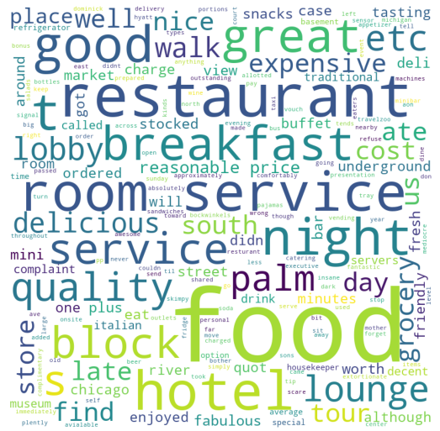

We can set a custom image as a mask to display the word cloud as follows:

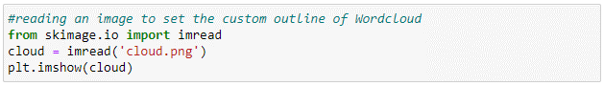

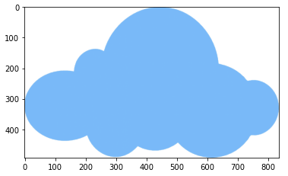

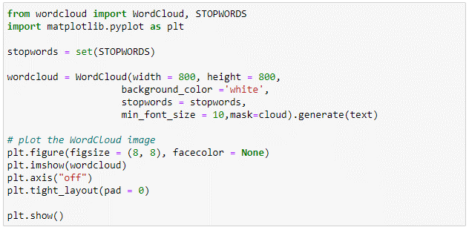

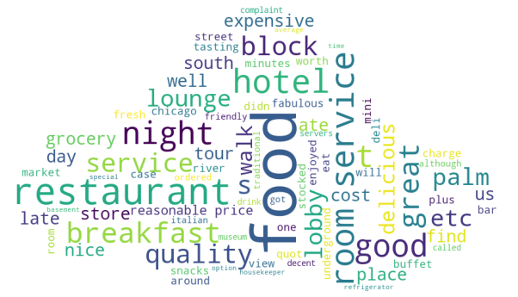

**References:**

1. <https://www.nltk.org/api/nltk.tokenize.html>
2. <https://basilkjose.medium.com/data-preprocessing-natural-language-competition-processing>
3. <https://towardsdatascience.com/text-preprocessing-in-natural-language-processing-using-python-6113ff5decd8>
4. Infosys Springboard – Natural Language Processing for developers